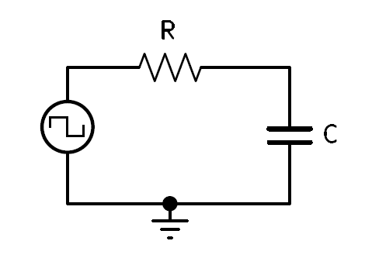Consider the following circuit:

**Integration (think averaging!)**

* “Integration is the summation of area.” (Bell p.50)
* There is not enough time for the capacitor to fully charge or discharge.
  1. PW or PS is less than $5τ$.
  2. “An integrating circuit is an RC circuit with the output taken across the capacitor and $RC≥(10×PW)$”(Bell p.53)
  3. The standard formulas for designing an Integrating RC circuit is:
 $RC= τ$

 $50\% DC, PW=PS$

 $PW=Time to charge, PS=Time to discharge$

 $RC≥(10×PW)$ + (Integration in terms of $τ$)
     + $Time =\frac{1}{10}τ$ (Integration formula in terms of Time, not enough Time to charge or discharge)
  4. Additional formulas (derived previously):
     + $\#of cycles?=\frac{5τ}{Period}$ (cycles)(stabilization)

$Vmax=\frac{V{gen}_{+}}{1+e^{\frac{-t}{RC}}}$

$Vmin= V{gen}_{+}-Vmax$

See Image:

1. Is **not** an Integrator, the capacitor is fully charging and discharging.
2. Is **not** an Integrator, $τ=$ PW. 63% charge and discharge
3. Is an **Integrator,** Vmax and Vmin will alternate minimally equal distance above and below the average input generator voltage.

